Create a custom JSON
Tasks
1.
Create a custom JSON-based policy in AWS IAM that allows read-only access to all objects in an S3 bucket named 'my-music-playlists', and attach this policy to a new user called 'playlistViewer'.
2.
Write an inline policy in JSON that allows a user to start and stop EC2 instances only with the tag Environment:Dev, and attach it directly to an existing IAM user named 'devOpsIntern'.<br><br><em><strong>Hint:</strong> Use 'Condition' in your policy to filter by tag.</em>
3.
Create a managed policy in AWS IAM that grants permission to list and view DynamoDB tables, then attach this policy to a group called 'appReviewers' which could represent users reviewing app data like Zomato order history.
4.
Given the following JSON policy, identify and fix the error that would prevent it from granting access as intended: <br><br> { "Version": "2012-10-17", "Statement": [ { "Effect": "Allow", "Action": "s3:GetObject", "Resource": "arn:aws:s3:::user-uploads/*" } ] } <br><br><em><strong>Hint:</strong> Check if the policy allows listing the bucket as well as getting objects.</em>
5.
Use ChatGPT to generate a JSON IAM policy that allows users to only update their own profile information in a DynamoDB table named 'UserProfiles', then review and test the policy in the AWS Policy Simulator.<br><br><em><strong>Hint:</strong> Ask ChatGPT for a policy with a condition that enforces users can update only their own data.</em>

Answer : Task 1: Create a Custom IAM Policy for Read-Only Access to an S3 Bucket

Goal
Create a policy that allows a user to view and download objects from the S3 bucket my-music-playlists.
Step 1: Open IAM
- Sign in to the AWS Management Console.
- Search for IAM.
- Click Policies.
- Click Create policy.

Step 2: Choose JSON
Select the JSON tab and paste the following policy:
{
"Version": "2012-10-17",
"Statement": [
{
"Effect": "Allow",
"Action": [
"s3:GetObject"
],
"Resource": "arn:aws:s3:::my-music-playlists/*"
},
{
"Effect": "Allow",
"Action": [
"s3:ListBucket"
],
"Resource": "arn:aws:s3:::my-music-playlists"
}
]
}

Little Info
- GetObject → Allows downloading/viewing objects.
- ListBucket → Allows seeing the list of files.
- No upload or delete permissions are given.

Step 3: Save the Policy
Click Next.
Policy Name:
MusicPlaylistReadOnly
Click Create policy.

Step 4: Create User
- IAM → Users
- Click Create User
- Name:
playlistViewer
- Continue through the wizard.
- On Permissions, choose
Attach policies directly
- Select
MusicPlaylistReadOnly
- Finish creating the user.

Task 2: Inline Policy for EC2 Start/Stop Only for Dev Instances

Goal
Allow the existing user devOpsIntern to start and stop only EC2 instances tagged:
Environment = Dev

Step 1
IAM → Users
Select:
devOpsIntern

Step 2
Go to
Permissions
↓
Add permissions
↓
Create inline policy
Choose JSON.
Paste:
{
"Version": "2012-10-17",
"Statement": [
{
"Effect": "Allow",
"Action": [
"ec2:StartInstances",
"ec2:StopInstances"
],
"Resource": "arn:aws:ec2:*:*:instance/*",
"Condition": {
"StringEquals": {
"ec2:ResourceTag/Environment": "Dev"
}
}
}
]
}
Name it:
DevEC2Control
Save.

Little Info
The Condition block checks the instance tag.
Only instances tagged like this can be started or stopped:
Key | Value
Environment | Dev
Any instance tagged:
Environment = Production
will be denied.

Task 3: Managed Policy for DynamoDB Read Access

Goal
Allow users to:
- List tables
- View table information
- Scan data
- Read items

Step 1
IAM
↓
Policies
↓
Create Policy
↓
JSON
Paste:
{
"Version": "2012-10-17",
"Statement": [
{
"Effect": "Allow",
"Action": [
"dynamodb:ListTables",
"dynamodb:DescribeTable",
"dynamodb:GetItem",
"dynamodb:Query",
"dynamodb:Scan"
],
"Resource": "*"
}
]
}

Name:

DynamoDBReadOnlyPolicy
Create it.

Step 2
Go to
Groups
Choose
appReviewers
↓
Permissions
↓
Add Permissions
↓
Attach Policies
Select
DynamoDBReadOnlyPolicy
Click
Add Permissions

Little Info
This policy lets reviewers:
✅ List tables
✅ Read data
❌ Cannot modify or delete data.

Task 4: Fix the Policy Error

Given Policy
{
"Version": "2012-10-17",
"Statement": [
{
"Effect": "Allow",
"Action": "s3:GetObject",
"Resource": "arn:aws:s3:::user-uploads/*"
}
]
}

Problem
The policy allows downloading objects but does not allow listing the bucket contents.
Without ListBucket, users may not be able to browse the bucket in the AWS Console.

Correct Policy

{
"Version": "2012-10-17",
"Statement": [
{
"Effect": "Allow",
"Action": "s3:GetObject",
"Resource": "arn:aws:s3:::user-uploads/*"
},
{
"Effect": "Allow",
"Action": "s3:ListBucket",
"Resource": "arn:aws:s3:::user-uploads"
}
]
}

Little Info
Remember:
Action | Resource
GetObject | arn:aws:s3:::bucket-name/*
ListBucket | arn:aws:s3:::bucket-name
Notice the /* is only used for objects, while the bucket itself has no /*.

Task 5: IAM Policy for Users to Update Only Their Own DynamoDB Profile

Goal
Allow users to update only their own item in the UserProfiles table.
This example assumes the partition key in the table is the user's IAM username.
{
"Version": "2012-10-17",
"Statement": [
{
"Effect": "Allow",
"Action": [
"dynamodb:GetItem",
"dynamodb:UpdateItem"
],
"Resource": "arn:aws:dynamodb:*:*:table/UserProfiles",
"Condition": {
"ForAllValues:StringEquals": {
"dynamodb:LeadingKeys": [
"${aws:username}"
]
}
}
}
]
}

Little Info
- UpdateItem → Allows updating an item.
- GetItem → Allows reading the user's own profile.
- dynamodb:LeadingKeys → Restricts access to items whose partition key matches the logged-in IAM username (${aws:username}).

Test the Policy in the AWS Policy Simulator
- Open the AWS Management Console.
- Go to IAM → Policy Simulator.
- Select the user (or paste the policy if testing standalone).
- Choose the DynamoDB service.
- Test actions such as:
  - GetItem
  - UpdateItem
- Try two scenarios:
  - Allowed: Partition key equals the user's IAM username.
  - Denied: Partition key belongs to a different user.
- Confirm the simulator shows Allow for the user's own profile and Deny for other users' profiles.

Quick Revision
Task | What You Learned
1 | Create a custom IAM policy for read-only access to an S3 bucket and attach it to a user.
2 | Create an inline policy with a Condition to restrict EC2 start/stop actions based on resource tags.
3 | Create a managed policy for read-only DynamoDB access and attach it to a group.
4 | S3 object access (GetObject) often needs ListBucket for browsing bucket contents in the console.
5 | Use the dynamodb:LeadingKeys condition with ${aws:username} to restrict DynamoDB access to a user's own records, and verify behavior with the IAM Policy Simulator.

Task 1: Read-Only Access to S3 Bucket

Real-Life Example
Imagine a music company stores songs in an S3 bucket.
Bucket Name:
my-music-playlists
Contents:
my-music-playlists
│
├── Pop/
│ song1.mp3
│ song2.mp3
│
├── Rock/
│ rock1.mp3
│
└── Jazz/
jazz1.mp3
User:
playlistViewer
Permissions:
✅ View files
✅ Download files
❌ Cannot upload
❌ Cannot delete

Diagram
IAM User
playlistViewer
│
│
Read Only Policy
│
▼
S3 Bucket
my-music-playlists
│
┌──────────────┐
│ song1.mp3 │ ✅ Read
│ song2.mp3 │ ✅ Read
│ jazz1.mp3 │ ✅ Read
└──────────────┘

Cannot Upload ❌
Cannot Delete ❌

AWS Console Example
The following image shows an IAM user with an S3 read-only policy attached.
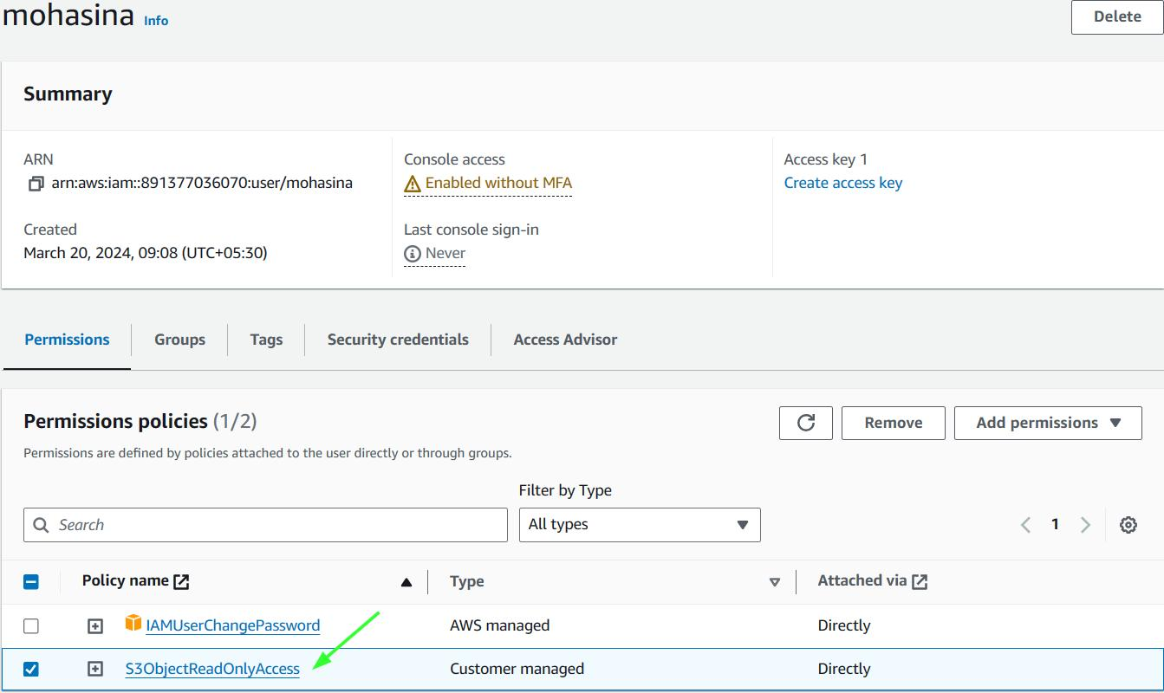
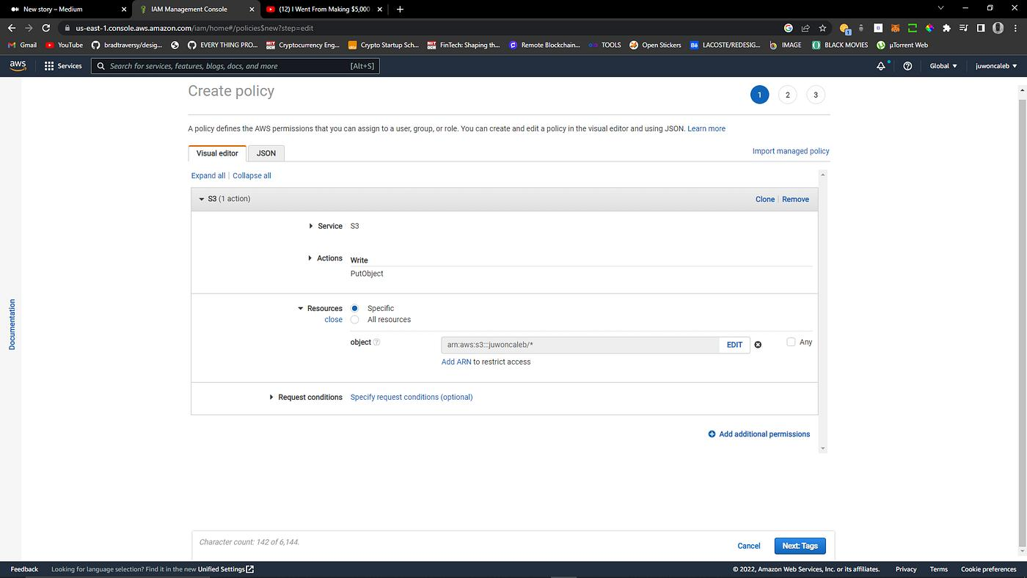
AWS recommends granting both s3:GetObject and s3:ListBucket when users need to browse and read objects through the console. (Amazon Web Services, Inc.)

Task 2: EC2 Start/Stop Only for Dev Servers

Example
Suppose your company has three EC2 instances.
Instance | Tag | Allowed?
WebServer | Environment=Dev | ✅ Yes
Database | Environment=Production | ❌ No
Testing | Environment=Dev | ✅ Yes

Diagram
devOpsIntern
│
Start / Stop Permission
│
Condition:
Environment = Dev
│
┌──────────────┼───────────────┐
│ │ │
Dev Server Dev Server Production
✅ ✅ ❌
The Condition in the IAM policy checks the EC2 tag before allowing the action.

Task 3: DynamoDB Read-Only Group
Imagine a food delivery app like Zomato.
Database:
OrderHistory
Example table
Customer | Order
Alice | Pizza
Bob | Burger
Charlie | Biryani
Group:
appReviewers
Permissions
View Orders ✅

Search Orders ✅

Delete Orders ❌

Edit Orders ❌
Diagram
appReviewers Group
│
DynamoDB Read Policy
│
▼
DynamoDB Table
OrderHistory

Task 4: Why Add ListBucket?
Suppose your bucket contains:
user-uploads
│
├── image1.png
├── image2.png
├── notes.pdf
Old Policy
GetObject
Result
Open image1.png ✅

Cannot see bucket contents ❌
Correct Policy
ListBucket
+
GetObject
Result
Open Bucket ✅

See Files ✅

Download Files ✅
Diagram
User
│
▼
user-uploads Bucket

Without ListBucket

❌ Cannot see files

With ListBucket

✅ image1.png
✅ image2.png
✅ notes.pdf

Task 5: Update Only Your Own Profile
Suppose the DynamoDB table looks like this:
Username | Email | Phone
Alice | alice@email.com | 111111
Bob | bob@email.com | 222222
Charlie | charlie@email.com | 333333
If Alice logs in:
She can update:
Alice
She cannot update:
Bob ❌

Charlie ❌
Diagram
Alice
│
▼
UserProfiles Table

Alice Profile ✅ Update

Bob Profile ❌ Denied

Charlie Profile ❌ Denied
The policy uses:
"dynamodb:LeadingKeys": [
"${aws:username}"
]
This means AWS compares the logged-in IAM username with the partition key in the DynamoDB table. If they match, the update is allowed; otherwise, it is denied.

AWS IAM Navigation (Where to Click)
AWS Console
│
▼
+--------------------+
| IAM Dashboard |
+--------------------+
│
├── Users
│ ├── Create User
│ └── Attach Policy
│
├── Groups
│ └── Attach Policy
│
├── Policies
│ ├── Create Policy
│ └── JSON Editor
│
└── Policy Simulator

Example Workflow

Login AWS
│
▼
Open IAM
│
▼
Create Policy
│
▼
Paste JSON
│
▼
Save Policy
│
▼
Create User/Group
│
▼
Attach Policy
│
▼
Test in Policy Simulator

Helpful AWS Documentation
If you want to learn more or compare your work with AWS examples:
- AWS IAM Documentation
- Amazon S3 Bucket Policy Examples
- AWS IAM Policies for S3 Walkthrough
These guides include additional examples and explain IAM policy elements such as Action, Resource, Effect, and Condition.

